Ideas:

* Sunglasses that enhance brightness
* Bottles with two sides
* Pen with a countdown
* Pen with two sides but the ink rises when flipped
* Double sided racket
* Heely’s Crocs

**Sunglasses that enhance brightness:**

Simple research shows electrochromic brightness-changing sunglasses – these are glasses that adjust to the sun’s brightness (tenth of a second)

Health and Safety:

* Could dry out the retinas
* Damage eyes with sunlight
* Damage skin around the eyes

Anything that could be added or removed:

* Head strap instead of temples/arms
* Speakers on the side of the frame
* Colour changing glasses

Form vs Function:

* Form will remain glasses style – it will be visible how/where you put it on
* Function will be discernible from the form

I think I could make it fit the brief

**Heely’s Crocs:**

Small search showed a third party make of it – lightning McQueen design

Anything that could be added or removed:

* LED rim – goes green when moving, red when it slows down
* Crocs change colour based on sunlight
* Built in socks (like football boots)
* Numberplate

Health and Safety:

* Lights could blind or distract someone
* Shoe could be too hot
* Wheel could pick up speed

**Slippery walking stick:**

Anything that could be added or removed:

* Ball/wheel will always lead to falling over

Health and Safety:

* Could cause people to fall over
* Ball could break leading to people not falling over

Form vs function:

* Form – a simple walking stick with the curved end
* Function – the function could be mistaken for a helpful walking stick, however it is designed to cause tripping and fall damage

**Spongebob hat:**

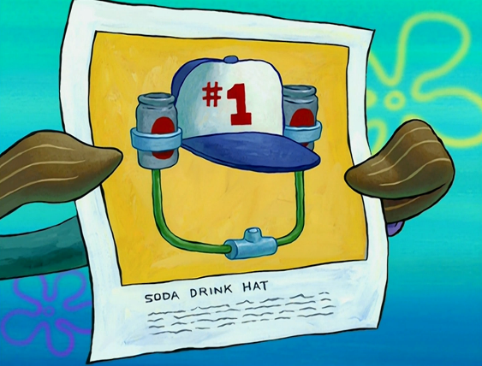

Anything that could be added or removed:

* An umbrella on top
* Safety net
* Watch that dispenses alcohol
* Pen that changes colour based on what it absorbs
* Bin keychain turn into a bigger one
* Bottomless bag – lounge inside of it